**EXPANDED INTERIORS AT HERCULANEUM**

**Catrin Huber**

**Press Images**

For large resolution files please email:

[lyndsay.short@newcastle.ac.uk](mailto:lyndsay.short@newcastle.ac.uk)

[rosanna.morris1@newcastle.ac.uk](mailto:rosanna.morris1@newcastle.ac.uk)

Photos copyright Amedeo Benestante

Images courtesy of Expanded Interiors, su concessione del MINISTERO DEI BENI E DELLE ATTIVITA’ CULTURALI E DEL TURISMO – PARCO ARCHEOLOGICO ERCOLANO & PARCO ARCHEOLOGICO POMPEI

Parco Archeologico di Ercolano - Ercolano Scavi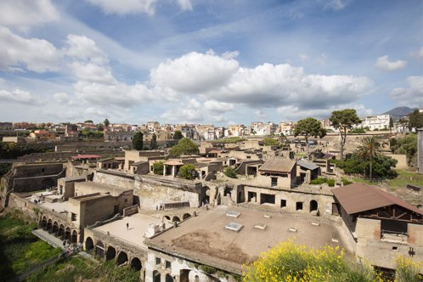

Catrin Huber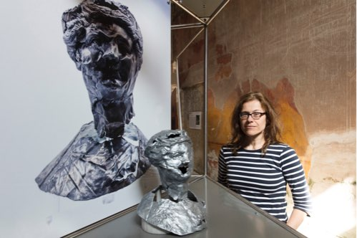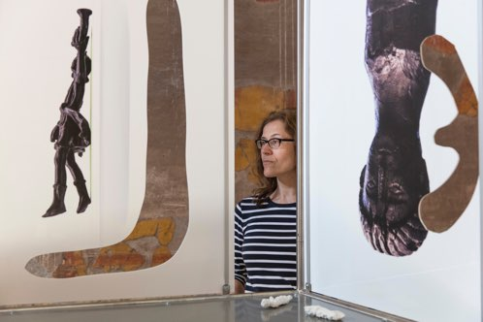

Expanded Interiors at Herculaneum - Front view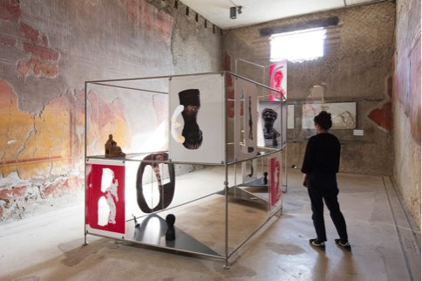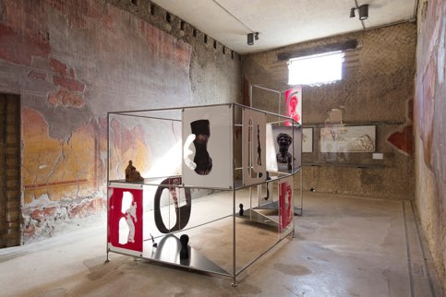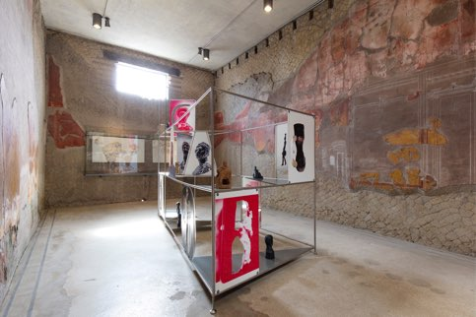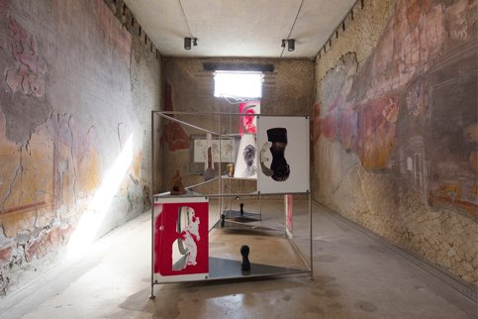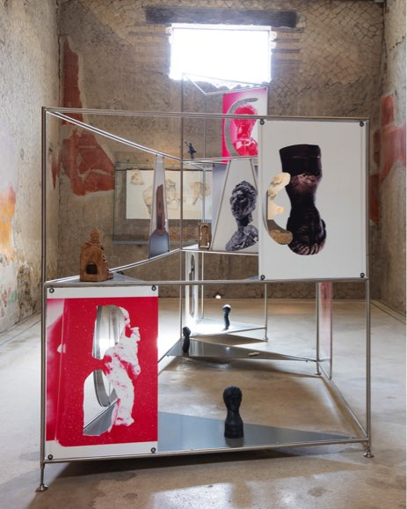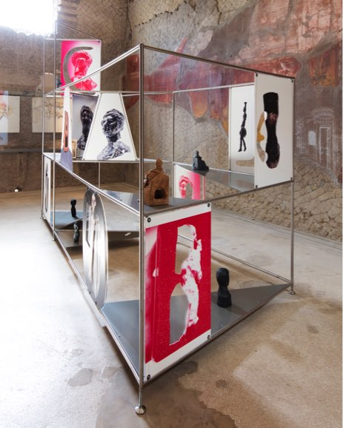

Expanded Interiors at Herculaneum - Rear view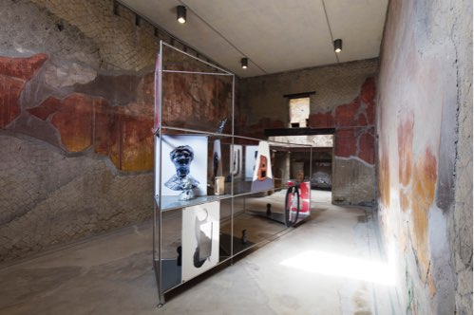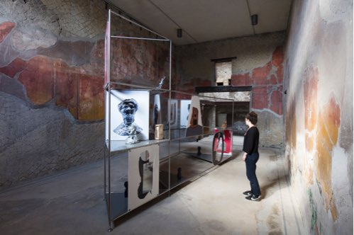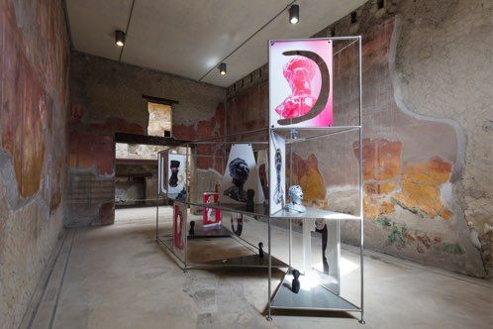

Expanded Interiors at 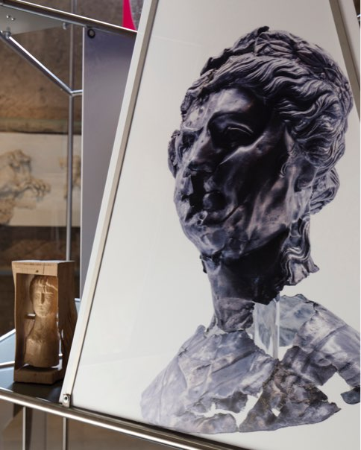Herculaneum - Details